Subject: DEADLINE EXTENDED TO NOV 30 - Call for submissions: International Society for Research on Emotion, July 15-18 2022, Los Angeles

**Apologies for cross-posting**

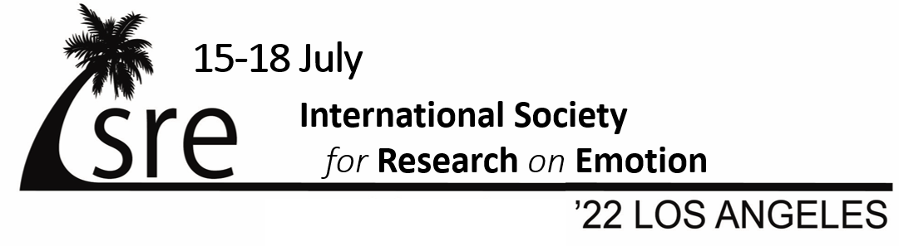
ISRE 2022 in person: Submission Deadline November 30, 2021

We are now accepting submissions and pre-conference proposals for the bi-annual ISRE (International Society for Research on Emotion) conference. The conference will take place in-person on the 15-18th of July 2022 on the campus of the University of Southern California, Los Angeles USA.

The ISRE conference is an exciting opportunity to meet international colleagues, present your work, and to stay up-to-date with the latest developments in emotion research. ISRE members study emotions from a wide range of disciplines including psychology, neuroscience, philosophy, sociology, linguistics, affective computing, history, anthropology, art and design. The ISRE conference 2022 will include keynote addresses by Antonio Damasio, Barbara Fredrickson and Eran Halperin.

If you would like to contribute to the ISRE conference by presenting your research, we invite you to submit an abstract of max. 250 words by November 30, 2021. Submissions are welcome from scholars in all relevant disciplines for symposia (of up to four talks and a discussant, or 5 talks), individual talks, and posters. Symposia are encouraged to include more than one discipline to facilitate cross-disciplinary exchange. Upload your contribution at the ISRE 2022 conference website (http://isre22.org). Please consult the guidelines on the website before preparing your contribution as submissions are subject to blind review and there are limits on the number of submissions from a single individual.

If you would like to organize a pre-conference, we will be accepting proposals up until November 30, 2021. Please email a 1 page PDF proposal to the pre-conference chairs, Gale Lucas (lucas@ict.usc.edu) and Rachael Jack (Rachael.Jack@glasgow.ac.uk). Proposals should include names and affiliation of the organizers, a 400 word max description and provisional line-up of speakers and topics.

All abstracts will be subject to blind peer review by an international scientific committee; accepted abstracts will be published in the conference program. Notification of acceptance decisions will be communicated in February 2022. Online registration is expected to be available shortly after that.

We are looking forward to welcoming you in Los Angeles in July 2022!

Jonathan Gratch and Stacy Marsella
Organizers, ISRE 2022 Conference

Program Chairs
Agneta Fischer, University of Amsterdam
Mary Helen Immordino-Yang, University of Southern California

Pre-conference Chairs
Rachael Jack, University of Glasgow
Gale Lucas, University of Southern California

PROGRAM COMMITTEE
Agnes Moors, KU Leuven
Andrea Scarantino, Georgia State University
Ann Frenzel, Ludwig Maximilian University of Munich
Batja Mesquita, KU Leuven
Carien van Reekum, University of Reading
Christian von Scheve, Freie Universität Berlin
Colin Holbrook, University of California
Merced David Osher, American Institutes for Research
Desmond Ong, National University of Singapore
Elly Konijn, Vrije Universiteit Amsterdam
Eric Walle, University of California Merced
Erika Rosenberg, UC Davis, Center for Mind and Brain
Hillary Elfenbein, Washington University of St. Louis
Julien Deonna, University of Geneva
Karen Quigley, Northeastern University
Lisanne Pauw, University of Münster
Mariska Kret, Leiden University
Nathan Consedine, University of Aukland
Olivier Luminet, Université Catholique de Louvain
Peter Kuppens, KU Leuven
Piotr Winkielman, University of California San Diego
Roger Giner-Sorolla, University of Kent
Rui Sun, University of Amsterdam
SIdney D’Mello, University of Colorado, Boulder
Stephanie Jones, Harvard University
Tobias Brosch, University of Geneva
Ursula Hess, Humbolt University

Career Development Chair
Tanja Wingenbach, University of Zurich

Submission Chairs
James Hale, University of Southern California
Tobias Thejll-Madsen, University of Glasgow

Website Chair
Giselle Pu, Pennsylvania State University

Publicity Chair
Teerawat Monnor, University of Geneva

