Journal of Cognitive Science

Journal of Cognitive Science is an official journal of the International Association for Cognitive Science (IACS, http://ia-cs.org) and published quarterly by the Institute for Cognitive Science at Seoul National University, located in Seoul, Korea. The Association currently consists of member societies of different countries such as Australia, China, Japan, Korea, and European Union. However, paper submission by anyone in the whole world is welcome at any time. Its main concern is to showcase research articles of highest quality and significance within the disciplines of cognitive science, including, but not limited to, philosophy, psychology, linguistics, artificial intelligence, neuroscience, aesthetics, anthropology, and education, insofar as it is deemed to be of interest to those who pursue the study of mind. In particular, we would like to encourage submissions that cross the traditional disciplinary boundaries.

Indexing:
Our articles are indexed in the following databases:
- SCOPUS
- Google Scholar
- ESCI (Emerging Sources Citation Index, Thomson Reuters)
- KCI (Korean Citation Index)

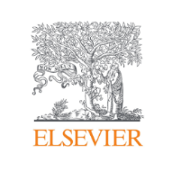
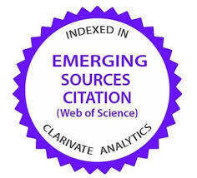

Aims & Scope:
The Journal of Cognitive Science (JCS) is published quarterly on 31 March, 30 June, 30 September, 31 December (founded in 2000) as the official journal of International Association for Cognitive Science (IACS) by the Institute for Cognitive Science at Seoul National University. It is a SCOPUS, ESCI, EBSCO, KCI journal. It aims to publish research articles of the highest quality and significance within the disciplines that form cognitive science, including philosophy, psychology, linguistics, artificial intelligence, neuroscience, anthropology, and education for Interdisciplinary Journal. Submissions that cross traditional disciplinary boundaries in either themes or methods are especially encouraged. AI-associated Cognitive Science will be newly reinforced and papers in this area are encouraged to be submitted.

Editorial Board:
- Editor-in-Chief:
Chungmin Lee, Seoul National University
- Editors:
Stella Vosniadou, Flinders University
Koiti Hasida, University of Tokyo
Kyoung-Min Lee, Seoul National University
Cameron Buckner, University of Houston

AI Assistant Editor: Taikyeong Jeong, CHA university

The Editorial Board and Advisory Editorial Board are listed on:
http://j-cs.org/editors/editors.php.

Submission Guidelines:
All submissions must be in English, written clearly and in sufficient detail that referees can assess the merits of the work. Papers should be no longer than 10,000 words and should conform to the JCS style guide (See For Authors on: http://j-cs.org/). Papers will be received anytime and processed as promptly as possible. All authors should upload their papers to JCS JAMS system(https://jcs.jams.or.kr/co/locale.kci?lang=en_US) or, if you find any difficulty, send an electronic copy(MS word) to j-cs@j-cs.org. Each submission will be sent to two or three reviewers. The reviews will be forwarded to the authors, who will then have an opportunity to make revisions if warranted.

