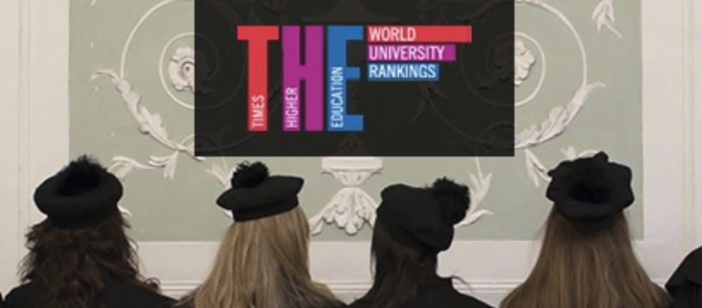

Doctoral Program in Cognitive Science

The annual call for 9 full funded positions for the Doctoral Program in Cognitive Science at the University of Trento will be soon open. As you will see from the links below, the call is open to several fields of cognitive science including Social and Affective Neuroscience.
• Announcement: https://www.unitn.it/en/node/1941
• PhD Application link: http://www.unitn.it/apply/dott
• Application Deadline: Thursday July 23, 2020, at 4pm (Italian time)
The Cognitive Science PhD programme:
• 3-yr program (Nov. 1, 2020- Oct. 31, 2023).
• Courses are in English
• 9 positions, 100% funded (6 positions in any of these research fields; 3 positions reserved for these specific topics)
• 6 months of research in a foreigner institution (+ 50% salary increase)
• Salary: starting at approximately €1.200/mo., net
• Winners receive a €3258 tax-free research/mobility budget
• PI and research topics: https://www.unitn.it/drsc/en/node/181
• The PhD programme: https://www.unitn.it/drsc/en/node/184
• Why choose UNITRENTO

To know more about research possibilities in the area of Affective Neuroscience, please contact Prof. Alessandro Grecucci at alessandro.grecucci@unitn.it or visit https://r.unitn.it/en/dipsco/clian

Please feel free to browse our website for further information, or contact the Head of the Doctoral Program, Prof. Maria-Paola Paladino mariapaola.paladino@unitn.it. For any information about admission procedure contact the Doctoral Program Secretariat at phd.dipsco@unitn.it.
Best Regards,
Alessandro Grecucci

