ANNOUNCING A NEW SPECIAL ISSUE
or, as we say in the Open Access, On-Line World,
A New Thematic Series
for Cognitive Research: Principles and Implications (CRPI)
The Psychology of Fake News
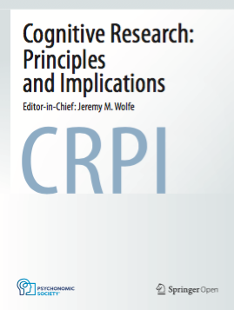
Co-organizers:
Professor David N. Rapp, Northwestern U, Evanston, IL (rapp@northwestern.edu)
Professor Holly A. Taylor, Tufts University, Somerville, MA (holly.taylor@tufts.edu)
Professor Jeffrey M. Zacks, Washington U.,
St. Louis, MO (jzacks@wustl.edu)

Media outlets, social critics, political organizations, and research groups have identified the problem of “fake news” as a critical contemporary concern. Fake news is false or made-up information that is presented to convince people of the validity of an idea in the face of a lack of true evidence for the idea—or even of evidence against it. Exposure to inaccurate information of this sort can lead to confusion about what is true, endorsement of incorrect ideas, and a willingness to share the inaccurate information. These risks, and potential strategies for mitigating those risks, can be explained in terms of cognitive processes associated with perception, comprehension, memory, decision-making, language processing, and problem-solving. Of course, social, communicative, and technological factors also moderate effects of fake news. The proposed special issue will highlight work that (a) identifies cognitive processes implicated in the detection and effects of fake news, (b) characterizes the consequences of fake news exposure across people’s diverse discourse experiences, and (c) identifies potential interventions that can help people overcome the allure of fake news. The overall goal is to develop accounts of when and why fake news informs people’s thoughts and behaviors, with specific attention to relevant cognitive and behavioral mechanisms. We invite you to contribute.

Please email the guest editors with any questions about submissions.

CRPI is the open access journal of the Psychonomic Society. Its mission is to publish use-inspired basic research: fundamental cognitive research that grows from hypotheses about real-world problems. As with all Psychonomic Society journals, submissions to CRPI are subject to rigorous peer review.

In case of need, the open access publication fee may be fully or partially waived. The authors should indicate when they submit a manuscript if they are requesting a waiver of the publication fee.

Deadline: manuscripts should be submitted before July 1, 2020
You can find manuscript submission details at
http://cognitiveresearchjournal.springeropen.com/submission-guidelines/preparing-your-manuscript

